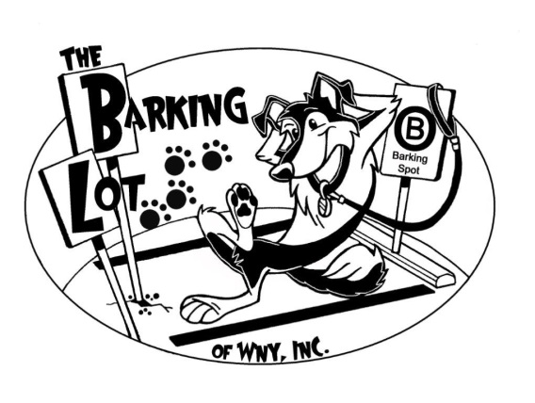
The Barking Lot of WNY, Inc., 5640 Maelou Dr., Hamburg, NY 14075 (716)649-4109
Daycare Registration Form- please print clearly
Owner Information
Name: ____________________________ Email: __________________________
Full Address: ________________________________________________________
Home Phone: ______________Mobile:_______________Work:_______________
Emergency Contact Information
Name:_____________________Home:______________Mobile:______________
Veterinarian Name/Phone:____________________________________________
Dog Information
Name:___________________Breed:____________________Age:_____________
Allergies/Medications? Explain._________________________________________
How would you best describe your dog? Circle all that apply.
Social Friendly Active Pushy Demanding Hyper Quiet Vocal Aggressive Fearful Dominant Nervous Reactive Possessive Bold Laid Back Shy

Signature:__________________________Date:___________________________

