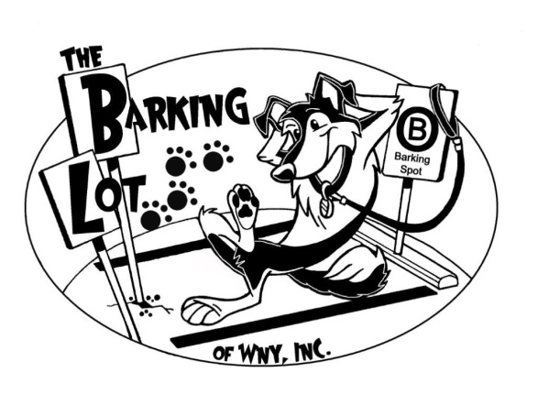
The Barking Lot of WNY, Inc., 5640 Maelou Dr., Hamburg, NY 14047 (716) 649-4109
General Rules and Guidelines (please read ALL of this information and sign)
The Barking Lot of WNY, Inc. provides a fun, safe and stimulating social environment for dogs 12 weeks and older. In order to ensure the health and safety of all of our canine clients, we require the following guidelines to be met.
Spaying/Neutering: Each dog’s health and wellbeing is of the utmost importance to us. We require all dogs to be altered by the age of 8 months. However, if you have concerns about early spay/neuter or your vet/breeder are encouraging you to wait until your dog is physically mature please discuss this with us and we are willing to be flexible based on each individual dog’s personality and temperament.
Vaccinations/Flea and Tick Treatments: ALL dogs that visit our daycare, classes, grooming and other events MUST be up to date on vaccinations. Upon enrollment, owners must provide recent proof of Distemper, Parvo, Rabies and Kennel Cough vaccinations as well as declare that each dog is treated with Flea/Tick preventatives. Titers are accepted in lieu of vaccines with the exception of Rabies which is required every three years by State Law.
Health: Owners must certify that their dog(s) are in good heath and have not been ill with a communicable condition within the last 15 days. Any dog(s) who have been ill, including intestinal parasites, within the last 15 days will require a letter or statement from their Veterinarian stating that he/she may be admitted back into our facility safely.
Behavior: All dogs must be friendly to canines and humans alike. Owners must certify that their dog(s) have not harmed or shown any aggressive behavior towards people or any other animal. For dogs who may require more of an individualized approach to socializing or need more specialized handling, we have a number of Enrichment Programs available as an alternative to our general Daycare Program.

Reservations: Due to the fact that we need to limit the number of dogs we can take in and properly care for at one time, we do require a reservation for our Daycare and Enrichment programs. We will do our best to accommodate your schedule whenever possible. We reserve the right to charge a full day’s fee for cancellations with less than 24hrs notices and for no shows.
Pick up and Drop off: Our facility is open for Daycare/Enrichment from Monday thru Friday from 7am-6pm. All dogs must be leashed and under control outside and inside our facility. Please refrain from allowing your dog to visit with other dogs in the parking lot or vestibule. This is the best way to prevent accidents or injuries and we appreciate your cooperation. We also ask that you pick up after your dogs.
Late Fee: As much as we prefer not to, we do require clients to pay a $1/minute fee for dogs who are picked up AFTER 6pm.
Please consider labeling you dog’s personal items such as leashes, collars or bags which may contain any medications, food, treats, etc. for ease in determining ownership at the end of each day.

Signature: _______________________________________Date:_______________________

